Tevon Edwards
Attorney

Tevon Edwards represents public schools and other local governments in all areas of school and municipal law.

PROFESSIONAL POSITIONS

Attorney, Porter Foster Rorick, 2018–present
CONTACT

Tel (206) 622-0203
Fax (206) 223-2003
tevon@pfrwa.com

Mathematics Teacher, Wilkerson Middle School, Birmingham, Alabama, 2012-15

EDUCATION

University of Washington School of Law, Seattle, Washington, J.D., with honors, 2018
Notes and Comments Editor, Washington Law Review
Order of the Coif

Reed College, Portland, Oregon, B.A., 2012
Academic Commendations, 2009-10, 2011-12

AREAS OF EXPERTISE

• Municipal law

• Public Records Act / FERPA

• Schools administration

• Labor relations

• Civil litigation
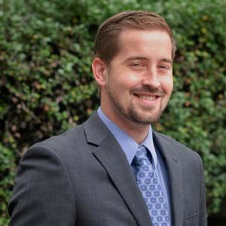

SELECTED PRESENTATIONS AND PUBLICATIONS

• Tevon Edwards, I Would Like to Request Your Academic Records: FERPA Protections and the Washington
Public Records Act, 93 Wash. L. Rev. 1057 (2018).

601 Union Street | Suite 800 | Seattle, Washington 98101| www.pfrwa.com

